Fuel-efficiency calculation:

METHOD1:
Done using Fuel injector duty cycle-
Formula used for fuel consumed at a particular RPM:
$$Fuel consumed (in cc)=\frac{RPM}{60}×\frac{\%dc}{100}×0.01×\frac{f}{60}×∆t×\frac{n}{2}$$
- RPM and Duty cycle data obtained from MoTec log files during test run
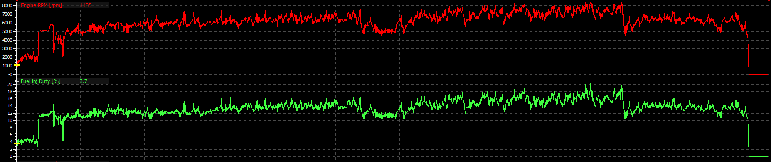
- A MATLAB code was written to calculate the fuel consumed during 30.637 minutes endurance run , extrapolating fuel consumption obtained from 10 minutes MoTec log data
- FOS of 1.2 on the Endurance lap time was considered for calculation

The code checks the amount of time the car has run in between each 1000 RPM starting form 0-1000RPM, 1000-2000RPM …. and so on.

Then an average RPM is calculated and the fuel consumed during the time of run in that mean RPM is obtained by mapping fuel injection duty cycle data
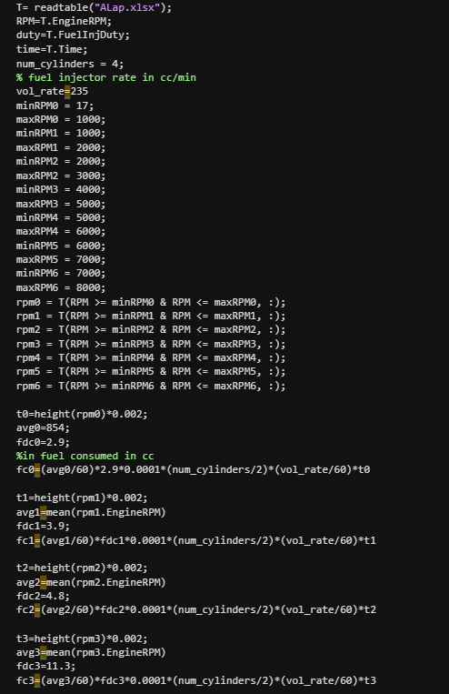

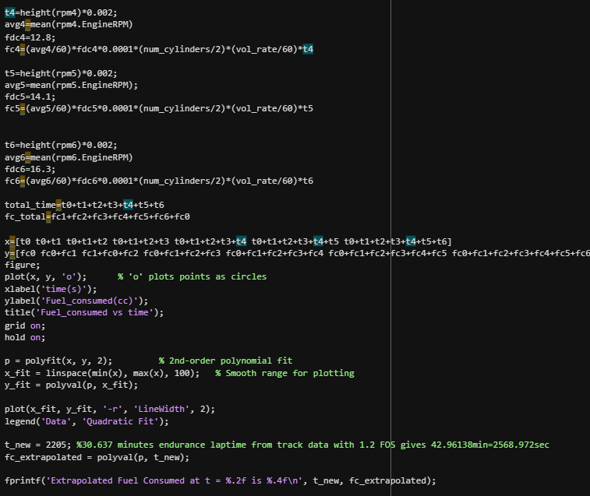

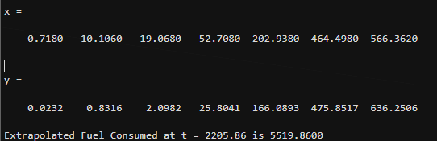

The fuel consumed value is 5519.86 cc or ml

METHOD 2:
Done using Fuel injector duty cycle-
Formula used for fuel consumed at a particular RPM:
$$Fuel consumed (in cc)=\frac{RPM}{60}×\frac{\%dc}{100}×0.01×\frac{f}{60}×∆t×\frac{n}{2}$$
%dc= duty cycle percent
F flow rate of injector=235cc/min
0.01=10 millisecond (reference duty cycle for each injector)
n= number of engine cylinder, n/2 is considered as during each
Data Used- Kari motor Speedway, track data of car obtained by simulation in OptimumLap
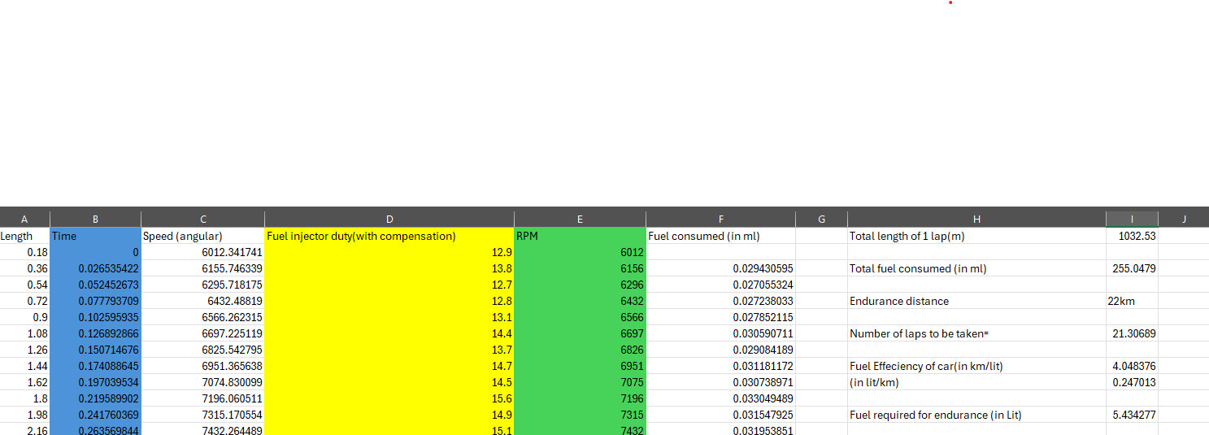
- Duty cycle from the duty cycle map of the car at various RPM was mapped with the RPMs at which the car ran during a single lap

The fuel consumed value is 5434.27 cc or ml
Error in the fuel consumption between two methods is =(5519.86-5434.27)=85.59 cc
%Error=(85.59/5519.86)*100=1.55%

Fuel tank design

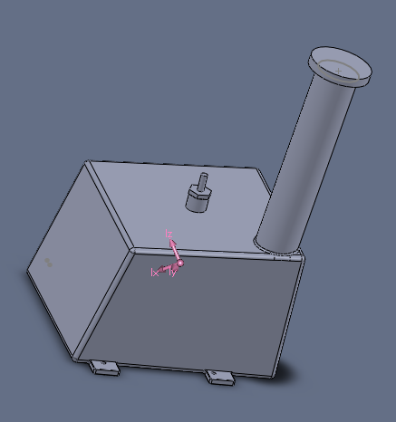
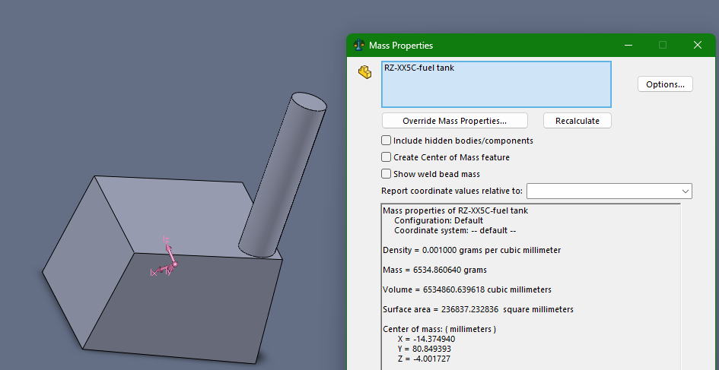
Old fuel tank
Old fuel tank volume model

- Volume(without fuel pump) = 6.534lit
- Approximate Volume occupied by Fuel pump =250ml
- Actual Volume= 6.534-0.35=6.184lit
- The old tank did not have of any baffles

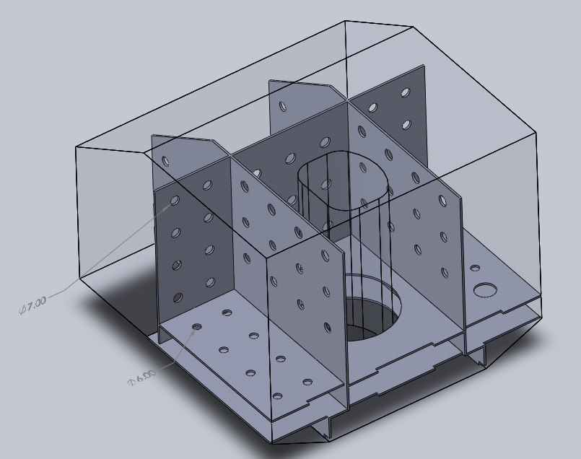
New fuel tank
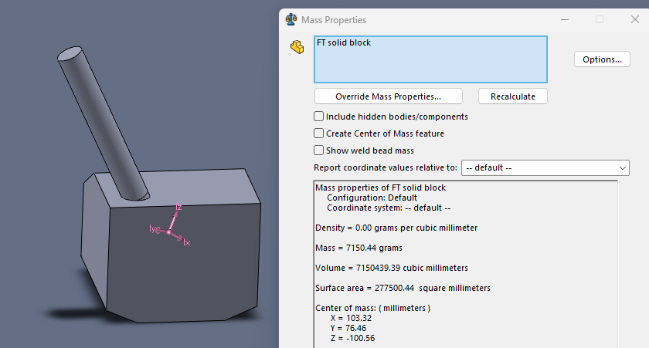
New fuel tank volume model

- Volume(without fuel pump)=7.15 lit, salvaged pump volume=0.250lit
- Volume occupied by baffles= 0.13 lit (1mm thick aluminum sheets used)

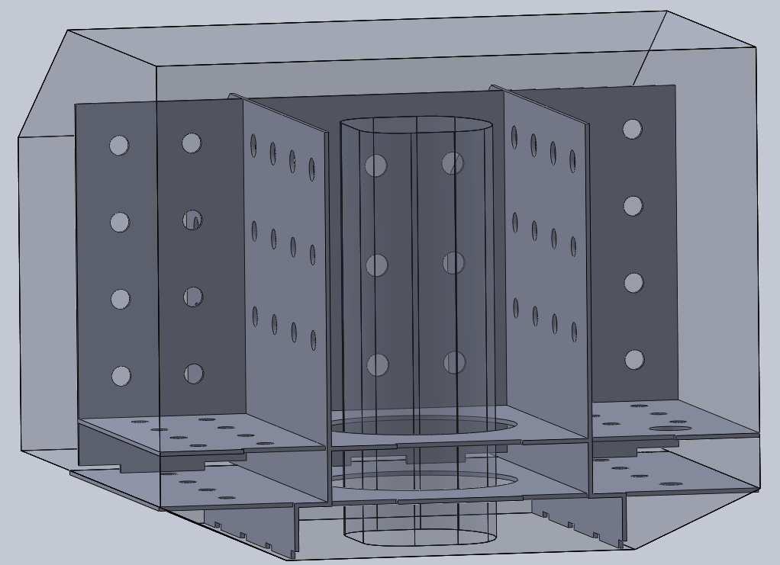

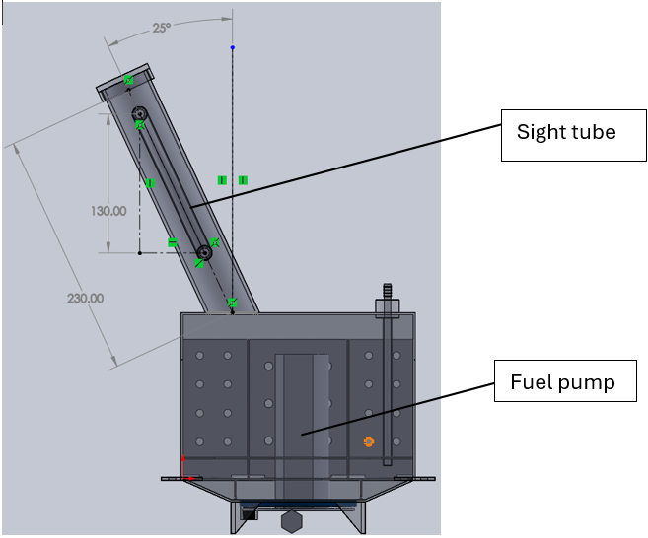
- Actual volume=7.15-(0.25+0.13)=6.77lit
- The bottom of the tank is made as a separate reservoir of volume close to 450ml, to prevent fuel starvation caused due to sloshing
- Bottom baffle plate hole diameter=6mm to prevent excess fuel leak from the bottom reservoir of tank , other baffle plate hole diameter=7mm
- The return line tube dumps the fuel directly to the bottom of the tank

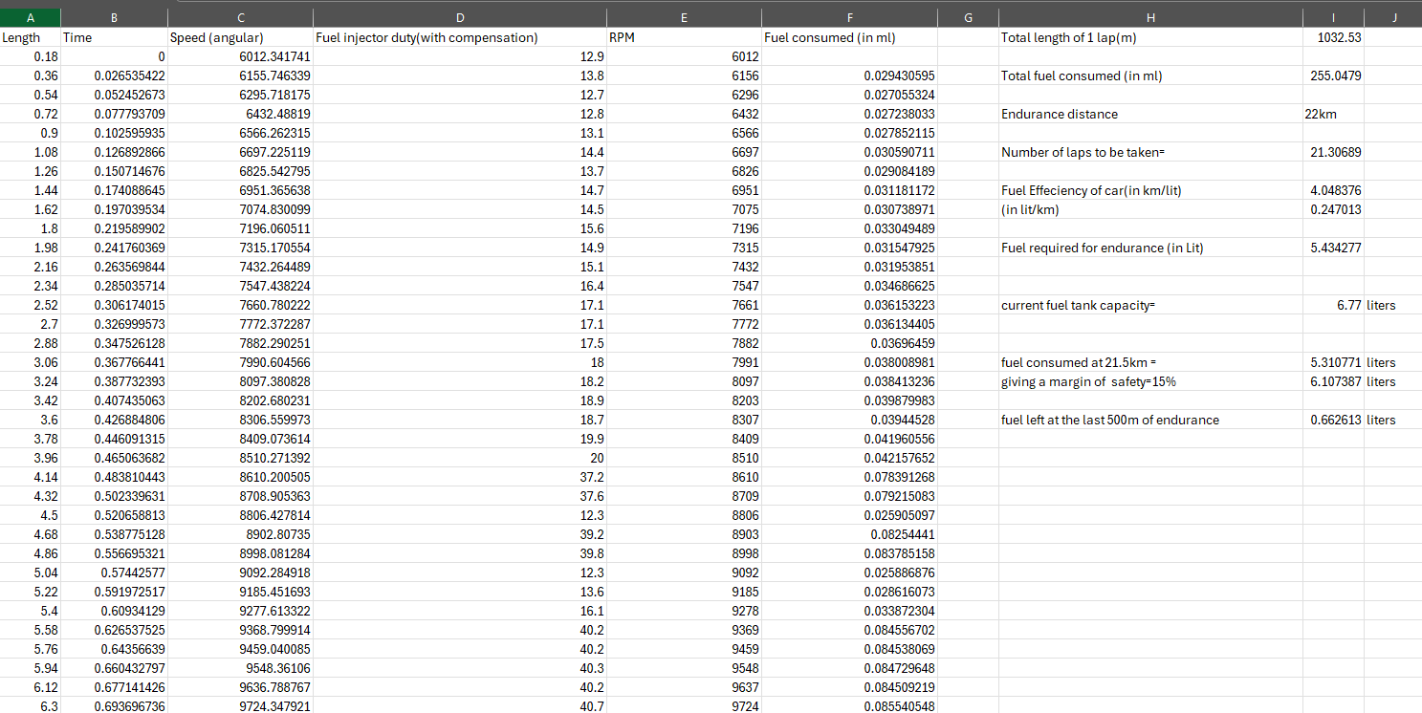
Slosh Simulation:

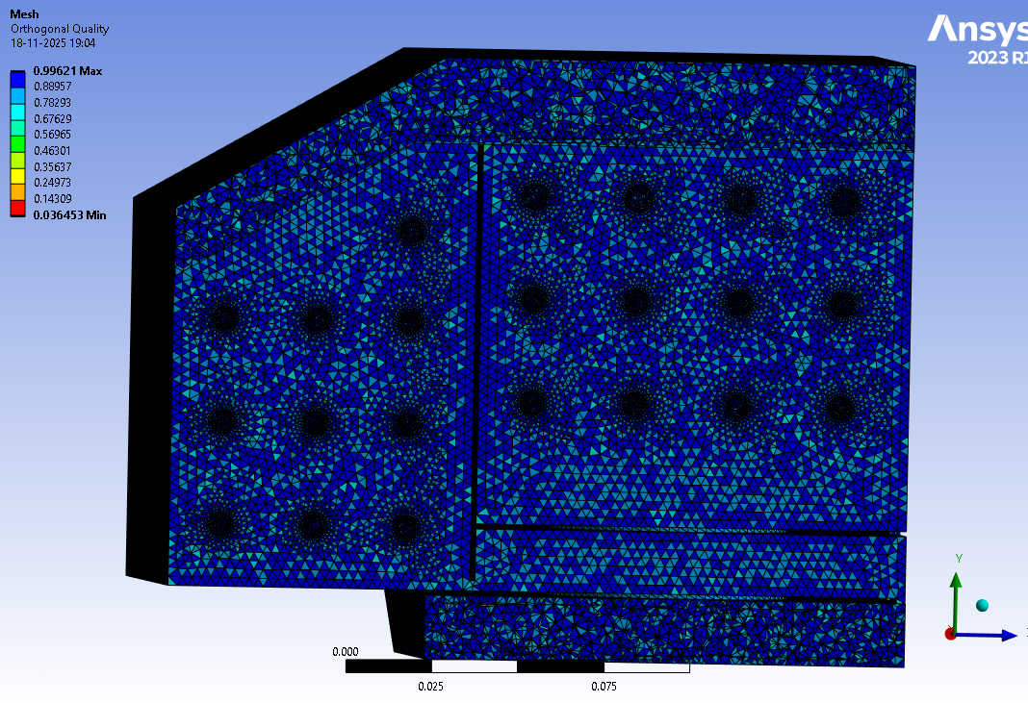
Mesh Quality
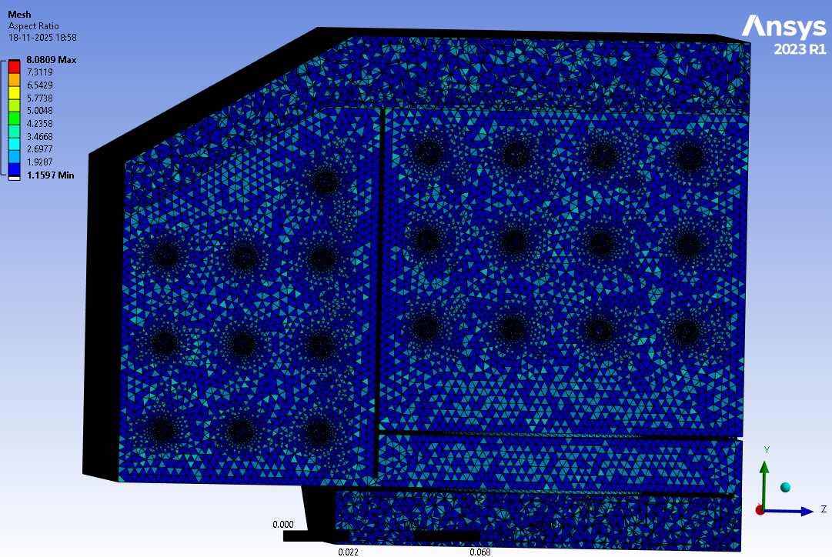
Avg Aspect ratio = 1.8674 Avg. Orthogonal Quality = 0.75363

Simulation Setup:
- Multiphase (VOF) model used with surface tension coefficient 0.021N/m
- Viscous Model – RANS $k-ω$ SST, with corner flow correction and production limiter
- Solution Method – Fractional Step (Pressure-Velocity Coupling), second order upwind used for better convergence

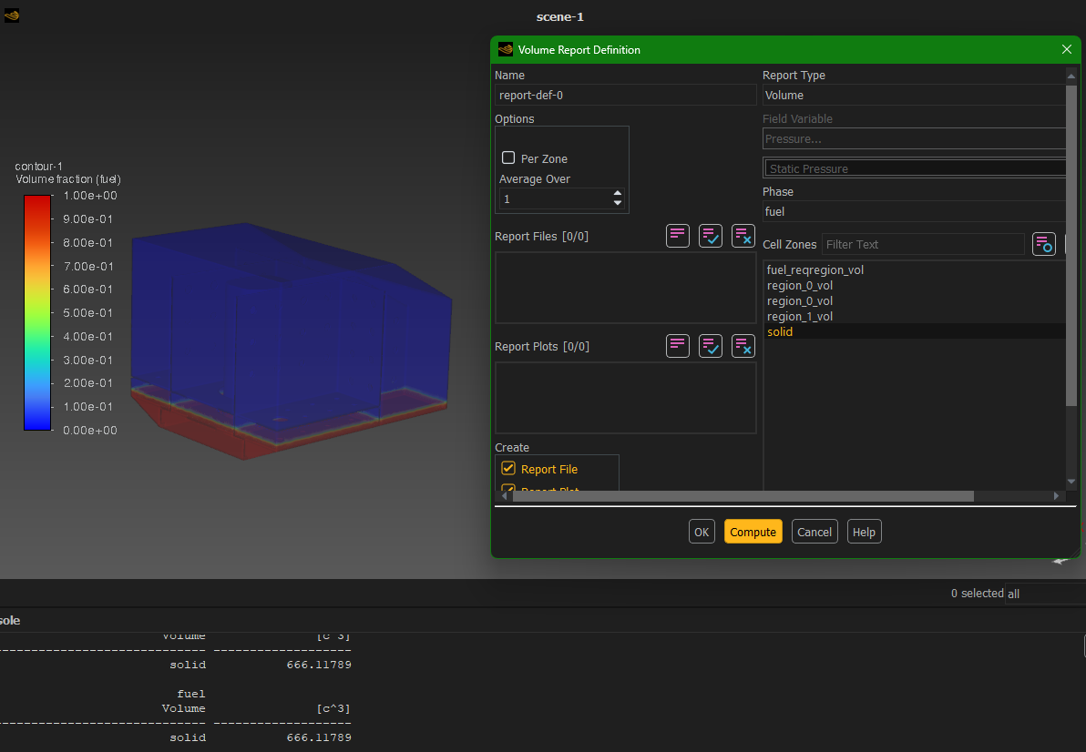
Slosh analysis was performed considering volume of fuel during the last 500m lap in endurance
The Volume considered for simulation = 666.1179m
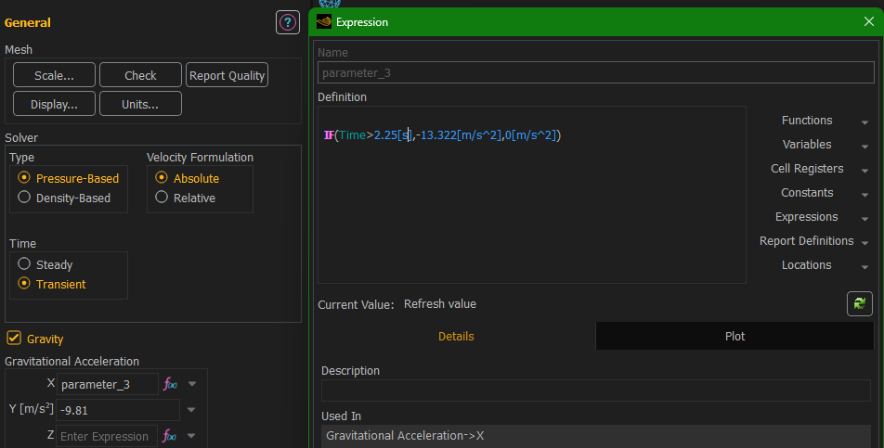
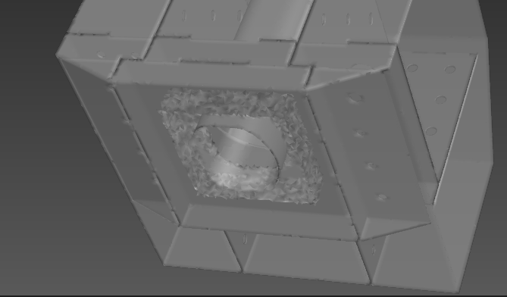
Region where fuel is monitored
Sloshing analysis was done for a lateral acceleration of 13.322 m/s² (1.358g, obtained from the suspension team goal), by providing acceleration in the negative X direction according to geometry orientation

Results
Fuel volume near base region of the tank was observed, to check for fuel starvation, and the volume of fuel was observed to be stable at close to 31ml which is very close to the fuel pump requirement for such a small duration of time.(Note: 30.555ml/s[110lit/hr] value derived from the fuel flow rate of GSX-r600 fuel pump)
The X-direction velocity remains stable.
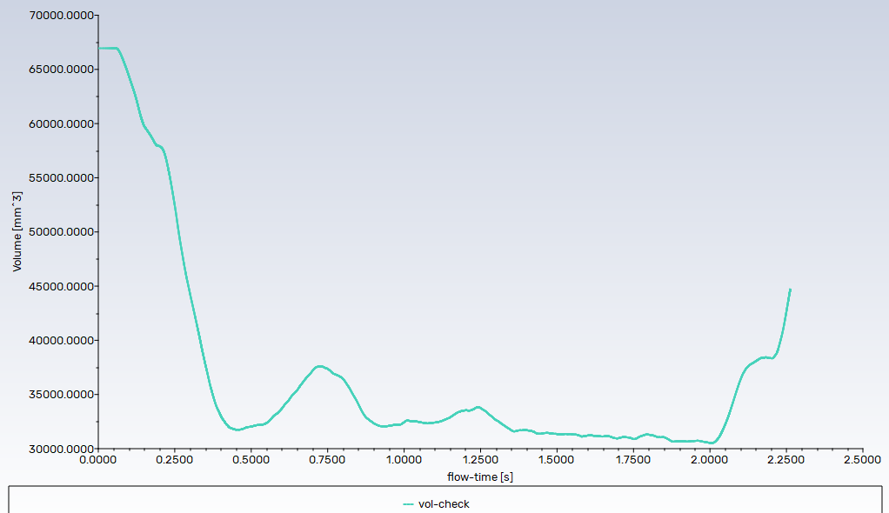
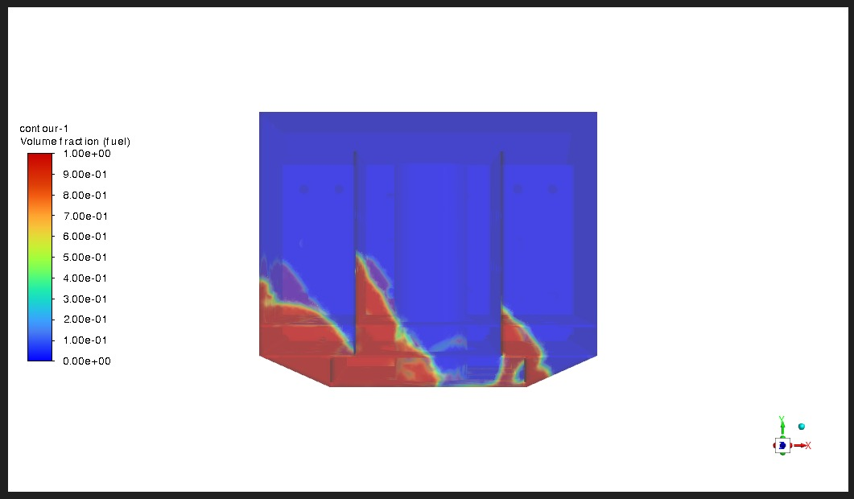

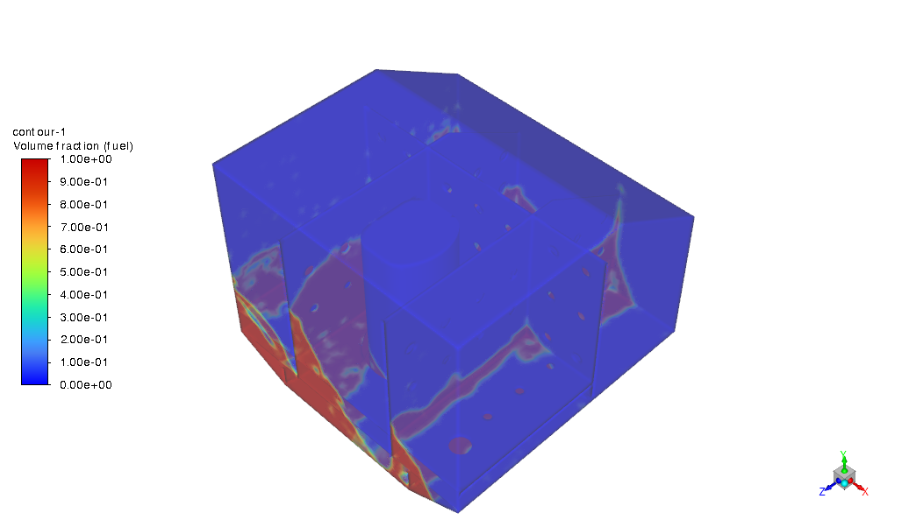
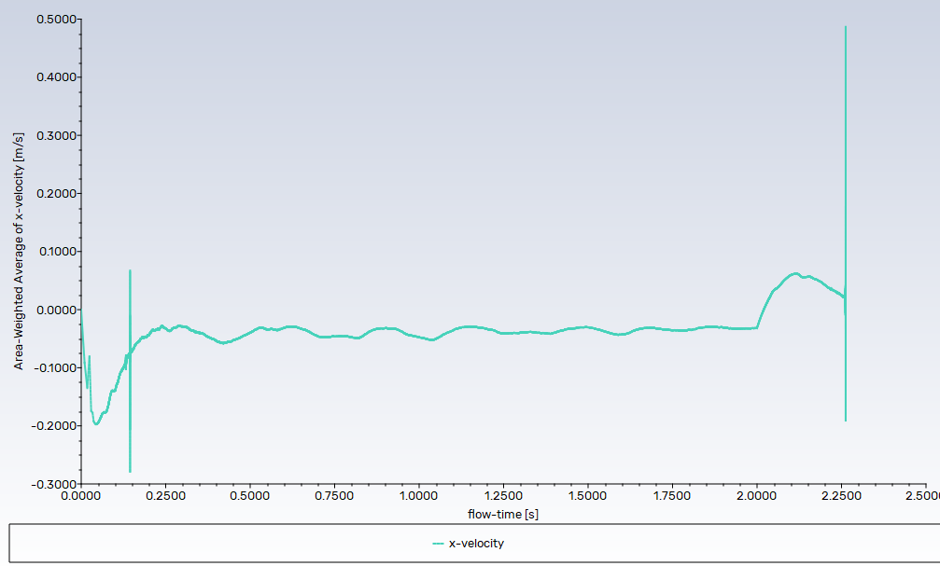

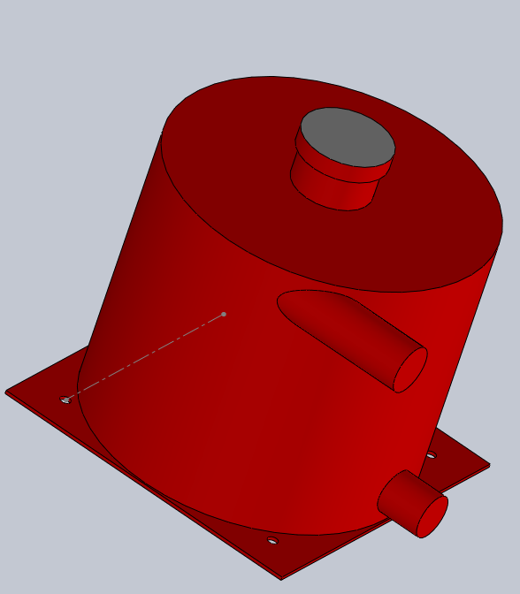
OIL TANK DESIGN

Old Tank
- Volume =3.94lit
- Cylinder diameter = 180mm

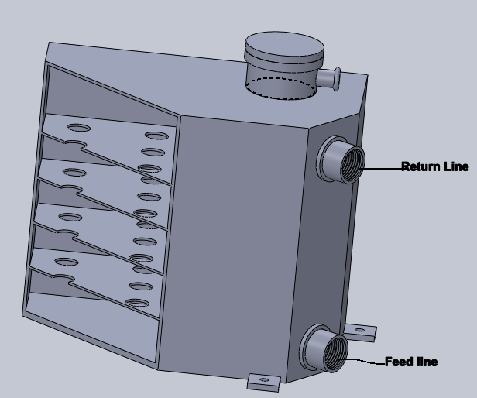
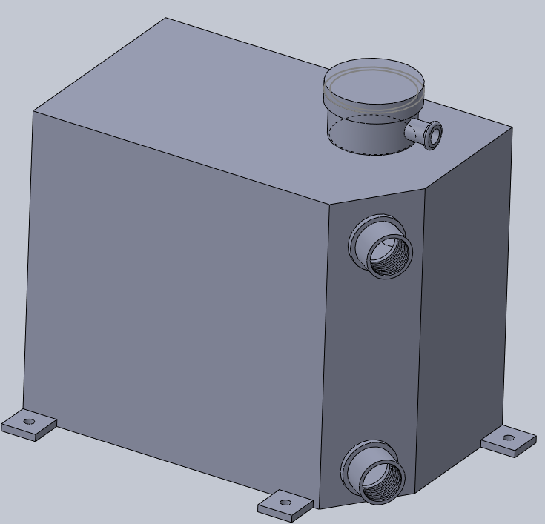
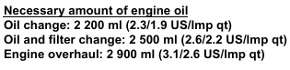
New Oil Tank
Volume of tank was decided based on
- Engine oil requirement when the engine was a dry sump (from GSX R600 service manual)
- The volume of oil that will be in return and feed line each of 1m long and internal diameter of 11mm, therefore volume of oil in the lines = $2×\frac{π×{(0.011)}^{2}}{4}$ = 0.1906 liters
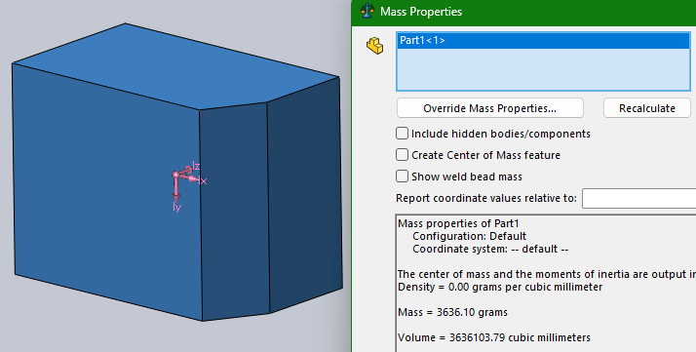
- When converting from wet to dry sump the oil volume is usually increased by 0.6-0.9 liters
Considering that the oil tank was designed with the volume= 3.636 liters
This includes volume occupied by baffles and the volume of oil that remains in the feed line = 0.127+0.1906=0.3176liters

Actual volume of oil available=3.636-0.3176=3.3184 liters
Which is 0.8184 liters more than the wet sump oil requirement of 2.5 liters
This volume is 0.304 liters lesser than the old tank

Design Features
- Horizontal baffles of hole diameter 15mm used, 25mm spacing between each baffle plate
- Baffle plates are placed right below opening of return line to minimize aeration
- New tank has width of 120mm for better packaging
- A flat side where the return and feed line adapters will be welded
- A positive stop opening near the cap is provided for catch can connection

Avg = 0.75759 avg= 1.8619

